Analysing the respective EV market in India using Market Segmentation Analysis

By Sohini Maiti

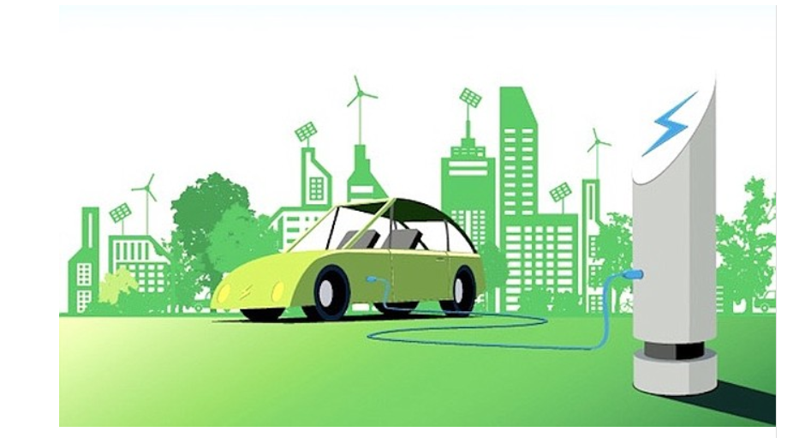

**Overview:**

An electric vehicle (EV) is a vehicle that uses one or more electric motors for propulsion. It is powered by one or more electric motors, using energy stored in rechargeable batteries. Unlike traditional internal combustion engine (ICE) vehicles, which run on petrol or diesel, EVs are driven by electricity, making them cleaner and more environmentally friendly. EVs include, but are not limited to, road and rail vehicles, surface and underwater vessels, electric aircraft and electric spacecraft.

The concept of electric vehicles dates back to the early 19th century. The first successful electric car was built by Thomas Davenport in 1834, and by the late 1800s, electric carriages were becoming popular. With the mass production of ICE vehicles by companies like Ford in the early 20th century, electric vehicles lost their market share due to the lower costs and longer ranges of petrol-powered cars. The late 20th and early 21st centuries saw a resurgence in interest in EVs, driven by advancements in battery technology, rising fuel costs, and growing environmental concerns. Companies like Tesla revolutionized the market with high-performance electric cars.

The electric vehicles industry at a nascent stage in India. It is less than 1% of the total

vehicle sales however have the potential to grow to more than 5% in a few years. At

present there are more than 5 lac electric two-wheelers and few thousand electric cars on

Indian roads. However it is growing rapidly due to increasing environmental concerns, government incentives, and technological advancements, changing consumer preferences.

Government initiatives like the FAME India Scheme, reduced GST on EVs, and state-level incentives have bolstered the EV ecosystem, encouraging adoption and infrastructure development. Two-wheelers lead the market due to their affordability and practicality for urban commuting. Companies like Ather Energy and Hero Electric have spearheaded this segment. Electric cars, though still emerging, show promise with models from Tata Motors, Mahindra Electric, and others gaining traction. Advances in battery technology have improved range and charging times, addressing key barriers to adoption. The expansion of charging infrastructure, including fast-charging stations, supports increased EV usage.

Electric vehicles are transforming the transportation landscape in India. Despite challenges, the market is poised for significant growth, making EVs a crucial component of India's sustainable future.

**Market Overview**

**The India electric vehicle (EV) market size was valued at USD 8.03 billion in 2023. The market is projected to grow from USD 23.38 billion in 2024 to USD 117.78 billion by 2032, exhibiting a CAGR of 22.4% during the forecast period.**

**India's electric vehicles recorded strong growth in 2023, supported by the government's implementation of favourable policies and programs. Uttar Pradesh held the maximum share in EV sales in 2023, India. The total units sold across all segments reached 2,77,837 followed by Karnataka with 1,52,324 units &Tamil Nadu with 90,241 units. Uttar Pradesh led the three-wheeler segment, while Karnataka and Maharashtra led the two-wheeler and four-wheeler segments. For instance, Mahindra & Mahindra also plans to launch 16 BEV, 8 each in the SUV and light commercial vehicle segment by 2027.**

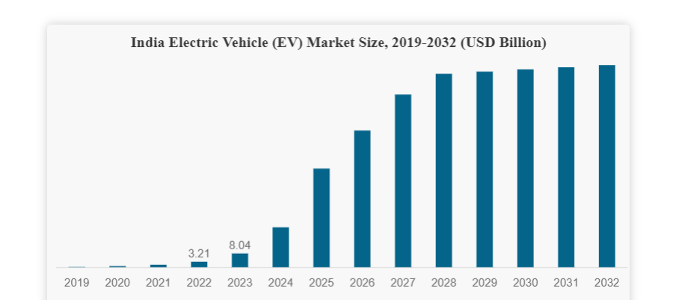

**Indian market is highly price-sensitive, and the majority of the Indian populace prefers two-wheelers for their daily transport due to rapidly growing traffic congestion. Therefore, in India low cost of electric two-wheelers and three-wheelers compared to four-wheelers, coupled with the high suitability of two-wheelers to Indian road traffic conditions, is anticipated to boost the adoption of electric two-wheelers and three-wheelers during the forecast period.**

**For instance, the cost of electric two-wheelers in India is nearly USD 600 to USD 3,755, which is significantly lower than the cost of electric four-wheelers. Some of India's most popular two-wheeler models include Revolt RV 400, Tork Kratos, and others.**

**Moreover, the Indian government's push toward e-mobility adoption by providing FAME India subsidies and inclining consumer preference towards electric micro-mobility is expected to boost the market in future years.**

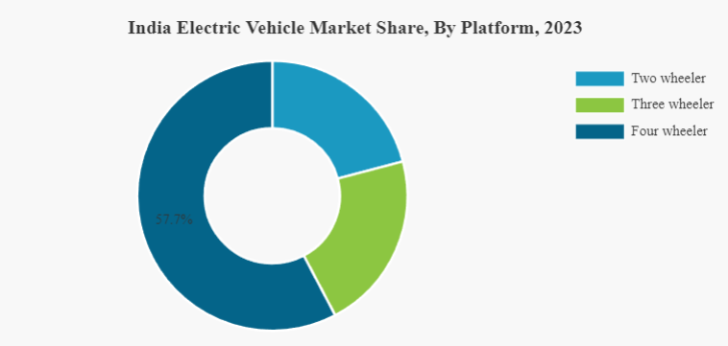

**EV market growth factors:**

* **Rising Fuel Prices to Boost the Market Growth during the Forecast Period**
* **Consistently Declining Cost of Electric Vehicle Battery to Drive Market Growth**

**Problem Statement**

As a team working under an Electric Vehicle (EV) Startup, we aim to analyze the Electric Vehicle market in India using Segmentation analysis. Our objective is to identify feasible strategies to enter the market, targeting the segments most likely to use their product in terms of Geographic, Demographic, Psychographic, and Behavioral to adopt Electric Vehicles. This involves segmenting the market based on various factors and proposing a comprehensive strategy for market entry.

**Fermi Estimation**

Fermi estimation is a method of making approximate calculations using rough assumptions and known data. We will use this approach to estimate the growth of the Indian EV market by 2025, considering the influence of an increasing employment rate.

Employment rate = it is the ratio of number of available labor force to the population of People in the working age.

• The Current Indian EV Market Size is estimated at 1.5 million units (including two-wheelers, three-wheelers, and passenger vehicles) in 2023.

**Growth Rate**: The current CAGR for the Indian EV market is 36%. And the employment rate is projected to increase by 5% annually. Assuming a positive correlation where a 1% increase in employment leads to a 1% additional growth in the EV market.

**Calculate the EV Market Size in 2025 without considering employment rate increase**:

* The EV market grows at 36% annually.
* Using the compound interest formula: A=[P(1+(r/100))]^n

Putting the estimated value we get that, A≈2.7744 million units

**Calculate the additional growth due to employment rate increase**:

* Employment rate increases by 5% annually, leading to a cumulative increase of approximately 10.25% over two years.
* Assuming a direct correlation, the EV market will grow by an additional 10.25% due to increased employment.

Additional Growth=2.7744×10.25/100

So, Additional Growth≈0.2846 million units

**Total EV Market Size in 2025**:

Total Market Size=2.7744+0.2846

Thus, Total Market Size ≈3.059 million units

**Conclusion**

Based on the Fermi estimation, the Indian EV market is projected to grow to approximately 3.059 million units by 2025, considering a 36% annual growth rate and an additional boost from the increasing employment rate. This estimation highlights the potential for substantial growth in the Indian EV market, driven by both market dynamics and macroeconomic factors.

**Data Collection**

Data was extracted from the various websites mentioned below for EV market segmentation.

* <https://www.fortunebusinessinsights.com/india-electric-vehicle-market-106623>
* <https://www.india-briefing.com/news/indias-ev-manufacturing-capacity-and-market-preferences-progress-25840.html/>
* <https://www.kaggle.com/datasets>
* https://data.gov.in/
* <https://data.worldbank.org/>
* <https://datasetsearch.research.google.com/>

**Columns explanations:**

1. ‘Brand’ and tells the manufacturers of electric vehicles.

2. ‘model’ tells the various of electric vehicles.

3. ‘AccelSec’, ‘Top Speed’, ’Power Train’ tells specification about the vehicles.

4. ‘Range_km’, ‘Fast_Charge’, ‘Plug_type’ and ‘Bodystyle’ tells us about range of vehicle per full charge, fast charging is provided or not, type of charging plug and body style of vehicle respectively.

5. ‘Seats’ and ‘Price’ tells about the number of seats available on vehicle and their price.

**Implementation Packages/Tools used:**

1. Numpy: To calculate various calculations related to arrays.

2. Pandas: To read or load the datasets.

3. SKLearn: We have used LabelEncoder() to encode our values.

**Data-Preprocessing**

**Data Cleaning**

The data collected is compact and is partly used for visualization purposes and partly for clustering. Python libraries such as NumPy, Pandas, Scikit-Learn, and SciPy are used for the workflow, and the results obtained are ensured to be reproducible.

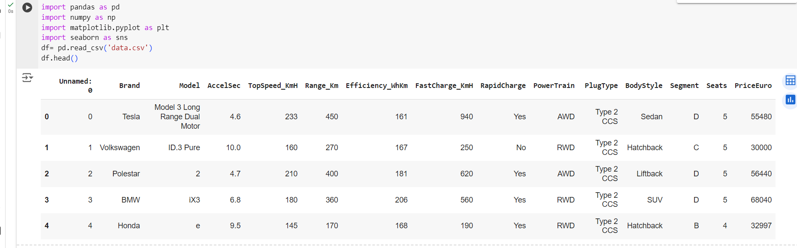

**Exploratory Data Analysis**

An Exploratory Data Analysis or EDA is a thorough examination meant to uncover the underlying structure of a data set and is important for a company because it exposes trends, patterns, and relationships that are not readily apparent.

We analyzed our dataset using univariate (analyze data over a single variable/column from a dataset), bivariate (analyze data by taking two variables/columns into consideration from a dataset) and multivariate (analyze data by taking more than two variables/columns into consideration from a dataset) analysis.

**Comparision of cars in our data**

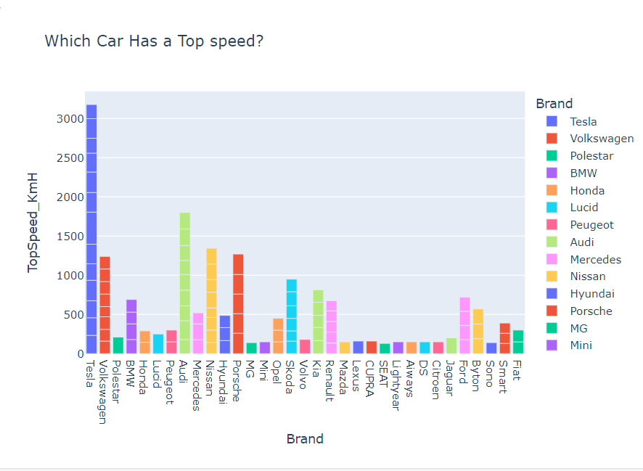

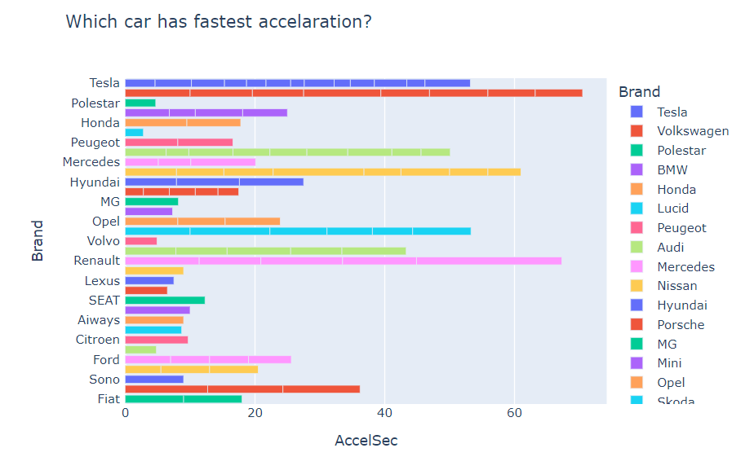

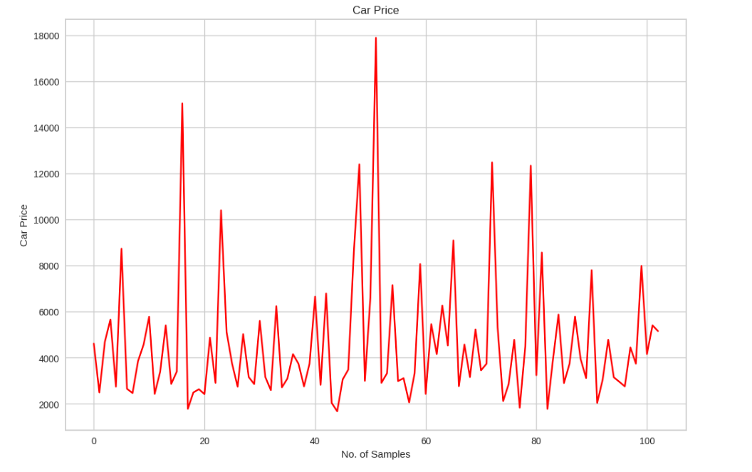

**Correlation Matrix**

A correlation matrix is simply a table that displays the correlation. It is best used in variables that demonstrate a linear relationship between each other. Coefficients for different variables. The matrix depicts the correlation between all the possible pairs of values through the heatmap in the below figure. The relationship between two variables is usually considered strong when their correlation coefficient value is larger than 0.7.

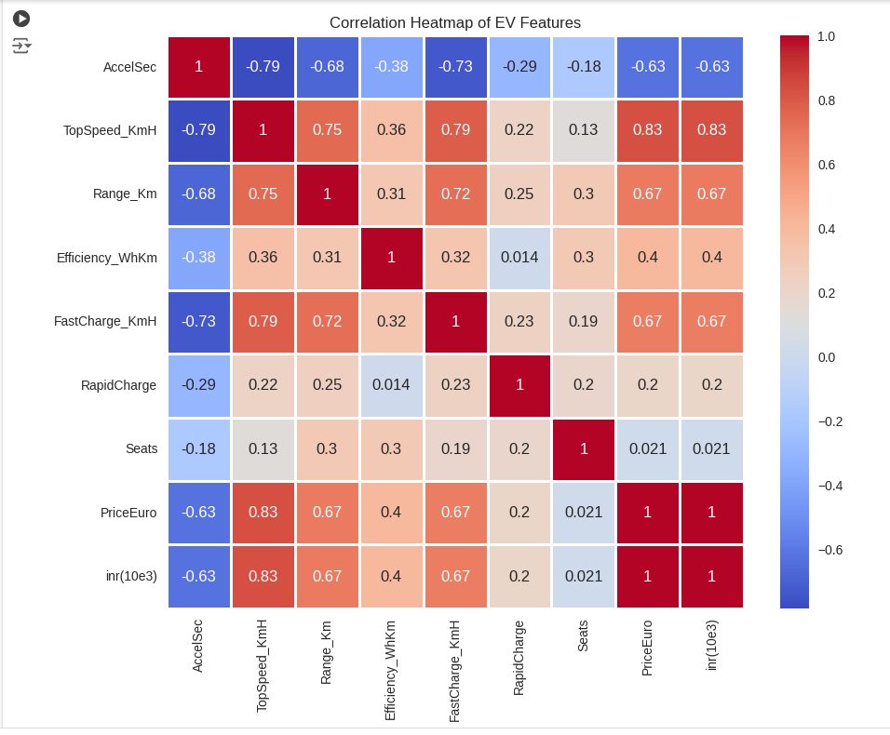

**Segment Extraction**

K-Means Clustering is one of the most popular Unsupervised Machine Learning Algorithms Used for Solving Classification Problems. K Means segregates the unlabeled data into various groups, called clusters, based on having similar features, common patterns. Suppose we have N number of Unlabeled Multivariate Datasets of various features like water availability, price, city etc. from our dataset. The technique to segregate Datasets into various groups, on the basis of having similar features and characteristics, is called Clustering. The groups being Formed are known as Clusters. Clustering is being used in Unsupervised Learning Algorithms in Machine Learning as it can segregate multivariate data into various groups, without any supervisor, on the basis of a common pattern hidden inside the datasets. In the Elbow method, we are actually varying the number of clusters (K) from 1 – 10. For each value of K, we are calculating WCSS (Within-Cluster Sum of Square). WCSS is the sum of squared distance between each point and the centroid in a cluster. When we plot the WCSS with the K value, the plot looks like an Elbow.

When we analyze the graph, we can see that the graph will rapidly change at a point and thus creating an elbow shape. From this point, the graph starts to move almost parallel to the X-axis. The K value corresponding to this point is the optimal K value or an optimal number of clusters. The approach k-means follows to solve the problem is expectation maximization The E-step is assigning the data points to the closest cluster. The M-step is computing the centroid of each cluster. Below is a break down of how we can solve it mathematically,

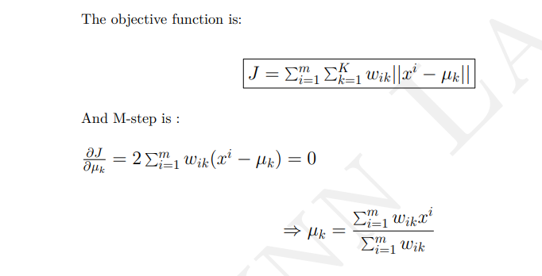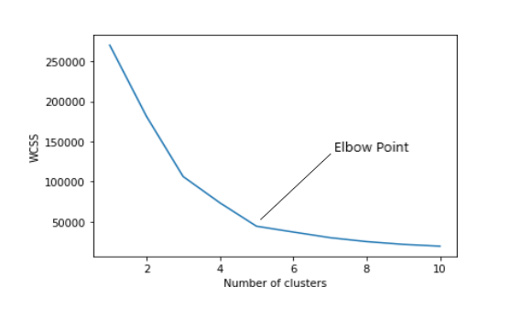

According to the Elbow method, here we take K=4 clusters to train KMeans model. The derived clusters are shown in the following figure.

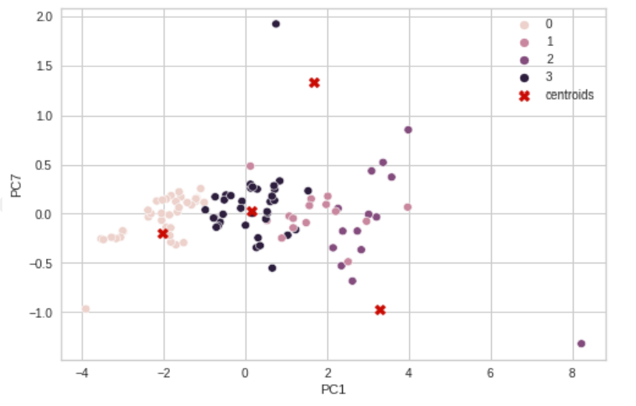

**Applications**

K means algorithm is very popular and used in a variety of applications such as market segmentation, document clustering, image segmentation and image compression, etc. The goal usually when we undergo a cluster analysis is either: 1. Get a meaningful intuition of the structure of the data we’re dealing with. 2. Cluster-then-predict where different models will be built for different subgroups if we believe there is a wide variation in the behaviors of different subgroups.

**Profiling and describing Potential Segments**

**Behavioral Segmentation:**

Segmenting the market based on customer behavior aspects suchas what price range customers usually buy in, what kind of specifications customers look for in their cars, etc.

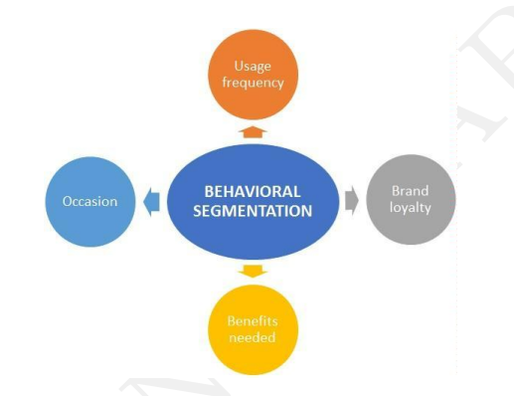

**Psychographic Segmentation:** Segmenting the market based on psychological parameters, such as the likes and dislikes of customers, whether they prefer comfort over speed of a vehicle, etc.

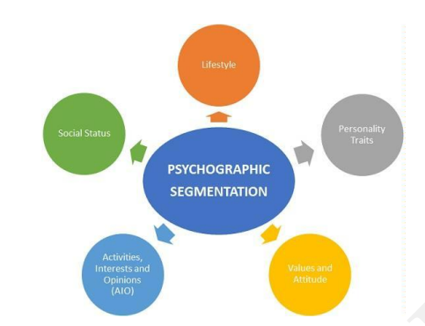

**Geographic Segmentation**: Segmenting the market based on geography. This mainly includes characteristics of the market based on the location.

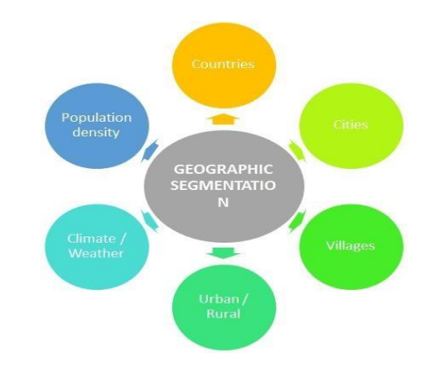

Pie Chart:

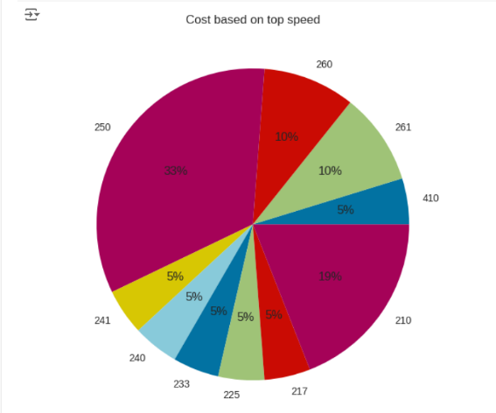

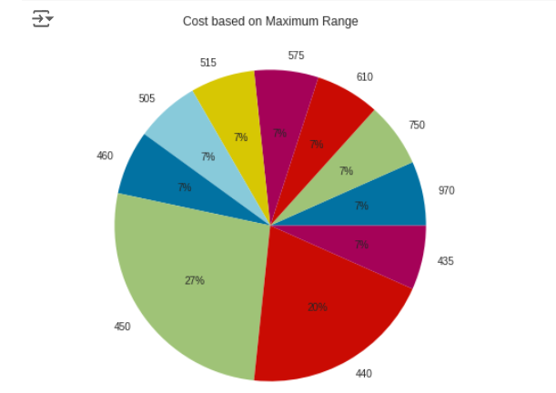

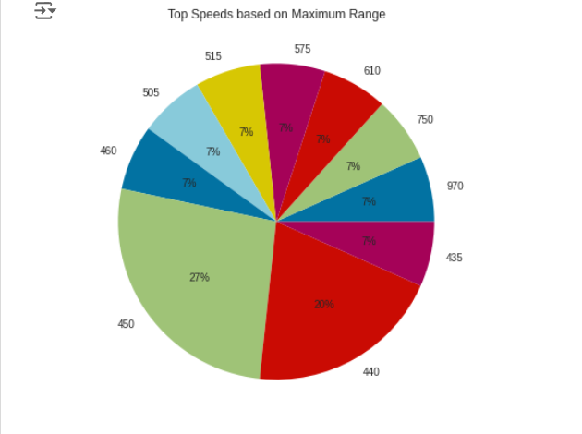

**Target Segments**

So, from the analysis we can see that the optimum targeted segment should be belonging to the following categories:

Behavioral: Mostly from our analysis there are cars with 5 seats.

Demographic:

* Top Speed & Range : With a large area of market the cost is dependent on Top speeds and Maximum range of cars.
* Efficiency : Mostly the segments are with most efficiency.

Psychographic:

* Price : From the above analysis, the price range is between 16,00,000 to 1,80,00,000.

Finally, our target segment should contain cars with most Efficiency, contains Top Speed and price between 16 to 180 lakhs with mostly with 5 seats.

**Customizing the Marketing Mix**

The marketing mix refers to the set of actions, or tactics, that a company uses to promote its brand or product in the market. The 4Ps make up a typical marketing mix -Price, Product, Promotion and Place.

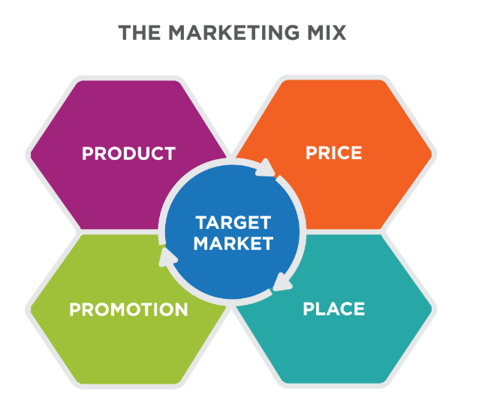

* **Price:** refers to the value that is put for a product. It depends on segment targeted, ability of the companies to pay, ability of customers to pay supply - demand and a host of other direct and indirect factors.
* **Product:** refers to the product actually being sold – In this case, the service. The product must deliver a minimum level of performance; otherwise even the best work on the other elements of the marketing mix won’t do any good.
* **Place:** refers to the point of sale. In every industry, catching the eye of the consumer and making it easy for her to buy it is the main aim of a good distribution or ’place’ strategy. Retailers pay a premium for the right location. In fact, the mantra of a successful retail business is ’location, location, location’.
* **Promotion:** this refers to all the activities undertaken to make the product or service known to the user and trade. This can include advertising, word of mouth, press reports, incentives, commissions and awards to the trade. It can also include consumer schemes, direct marketing, contests and prizes.

**Potential Sales in Early Market**

Purchasing a vehicle is one of those life accomplishments that top nearly everyone’s bucket list. The majority of the customers have a family. For such folks there are a variety of reasons, including market and schooling. Whether you prefer a modernized urban loft or a sprawling suburban home with a white picket fence, most of us hope to find a vehicle that feels like it was made specifically for our family. Here is where our insights come in to assist such people to find a best vehicle at the best-fixed price according to the area and several other factors.

Some of the key points required to focus for the development of EV in India are:

1. Retrofitting conversion of Public Transport (Bus), Taxi and Three-Wheeler (Auto) to PHEV: This is one of the key requirements to move towards sustainable transportation. It will not only balance emissions but also reduce the load on infrastructure requirement.

2. Government Incentives: Another key factor for XEV market to lift up will be identification of strategic incentives for electric vehicles. This will increase adoption rate and decrease main element barrier of the price of electric vehicles to customers. The incentive can be subsidy scheme for electric vehicles bridging gap price between the conventional and electric vehicle in similar performance range. e.g., if the cost of internal combustion engine car is INR 5 lakh and that of the electric vehicle is INR 6.5 lakh, the government can intend to offer discount or subsidy of the differential cost. In addition, benefit of Discount on VAT//Discount on Registration/Discount on Toll Plaza to motivate sell of EV can be planned.

3. Development of Skilled Manpower: Consideration of safety and advanced technology involved, development of certified skilled technician and professionals is one of the requirements.

4. Awareness: Awareness on benefits of XEV and promotions of the government can play a significant role in development. It can be done with the help of extensive advertisement at airport/bus station/cinema halls/government offices/public places using banners/hoardings, use of print media-newspaper/magazines/periodicals, digital media/radio/e media-internet, TV shows, expert talks, providing micro-funding for projects/conferences in schools, colleges and industry, supplying R & D grants to research scholar/institute/industry.

**Most Optimal Market Segment**

There are many EV manufacturing companies in the country like Hero Electric, Tata Motors, Ather Energy, Ashok Leyland, Hyundai Kona Electric, etc. Tesla has also arrived; the demand will get higher & higher since it is automotive so the investments and policies and all that would be bigger but it will take some time to perfectly settle in India. The following are the key insights of the project:

* The electric vehicle industry has not done that much good due to the devastating hit of the Covid outbreak but it will take a huge jump in upcoming years.
* The use of EVs will be game-changing in terms of environment, air, noise pollution-free, postelectric, and much more.
* The company should plan to establish local operations in India either by partnering with a local company or by setting up its own manufacturing/ development unit, potentially combined with imports of specific components.
* The company would expect to further grow in India, underpinned by a growing commercial fleet market for two-wheelers and three-wheelers especially for last km delivery/urban freight services. The company must see opportunities across the supply chain in the battery, EV component and charging infrastructure segments including the machinery and equipment needed for establishing manufacturing plants, training and provision of skilled workforce etc.
* The company should start their business from Metro Cities in India and then after considerable business expand to other cities of the same state of the Metro Cities. This will help the company to expand easily as they will be having a prior knowledge of business from Metro Cities and Network of Supply chain will be easy for the company as the time goes in business.

**GITHUB LINK: https://github.com/MSohini12**